Attention
The Minister of Finance, Mr. Simon Harris, TD.

Title
Energy Security Response to Closure of the Strait of Hormuz

Purpose
This briefing recommends urgent measures to mitigate the effect of energy price spikes in response to closure of the Strait of Hormuz.

Executive Summary
The Strait of Hormuz has been closed indefinitely in response to escalating tensions between Iran and the United States. This has global significance, as 20% of the world's oil and liquified natural gas (LNG) passes through the Strait. There is no immediate path towards reopening the Strait, and immediate government action must be taken to avoid an energy crisis.
International consensus estimates average global energy prices will triple imminently. The 2022 energy crisis illustrated Ireland’s vulnerability to supply shocks, and the potential for even more extreme price spikes if action is not taken.
The challenge is to minimise the impact to energy affordability for consumers and businesses while ensuring security of supply, taking due consideration of the country’s binding climate targets.

Policy Recommendations
- Reinstate quarterly energy payments of €250. Do not adjust energy VAT or PSO levy.
- Raise the Fuel Allowance by €5 / week and implement quarterly reporting on energy poverty.
- Commit to delivering the Strategic Gas Emergency Reserve by December 2027.
- Convene the Energy Security Emergency Group to deliver supports outlined in the National Energy Security Framework, adjusting for points 1-3 above.

Problem Context
The current escalation of tensions between Iran and the United States began with U.S. withdrawal from the Joint Comprehensive Plan of Action (JCPOA) in 2018. The JCPOA had limited Iran’s nuclear programme in return for removal of international economic sanctions. Iran has since grown and its stockpile of enriched uranium, a process necessary to develop nuclear weapons. On June 22, 2025, the U.S. bombed three nuclear facilities in Iran, aiming to disrupt the enrichment programme. Although reportedly successful, the operation has further heightened diplomatic tensions. Recently, a cost-of-living crisis in Iran has prompted wide-spread protest in the country, as well as threats of U.S. military intervention in response to a brutal government crackdown.
Closure of the Strait of Hormuz is the most recent escalation of these tensions. One-fifth of the world’s Oil and Liquified Natural Gas (LNG) pass through the Strait. Global energy prices have already spiked in response to this and there is analyst consensus that prices will rise as far as 300% above pre-closure levels.
The EU decision to phase out Oil and Gas imports from Russia by late 2027 adds complexity to any proposed policy response. Ireland is particularly vulnerable to an energy crisis. Oil and Natural Gas account for 49% and 30% of our Primary Energy Requirement and almost all of this is imported (Sustainable Energy Authority of Ireland, 2024). Additionally, the country has no natural gas storage facility beyond what is in the pipeline network and the declining Corrib gas field.

Problem Analysis
Retail price dynamics of oil and natural gas, materialising in response to closure of the Strait, are summarised below:
- The majority of Ireland’s oil products are imported from the United States. Although not directly sourced through the Strait of Hormuz, global wholesale oil prices are highly correlated, particularly when supply is constrained. The retail price of oil products has risen steadily as a result of fears that Iran might close the Strait of Hormuz and has spiked since its closure.
- Ireland imports 90% of its natural gas from the United Kingdom through the Moffat/Loughshinny pipeline (Central Statistics Office, 2023). The United Kingdom itself relies on domestic production and imports from Norwegian reserves. Similar to oil, wholesale pipeline natural gas is correlated strongly with the price of Liquified Natural Gas in times of supply shortage, and regional prices are correlated through global supply and demand dynamics. The price rise of natural gas in Ireland has been less extreme and lagged behind the rise in oil due to the hedging strategies of Irish gas suppliers. Prices are likely to rise further as these strategies expire and costs are passed to consumers.
The effect on retail energy prices is felt most significantly by consumers and Industry through:
- Electricity Prices: The wholesale price of electricity in Ireland is set by the marginal cost of generation, which is almost always gas fired (Esb, 2025). Figure 1 illustrates the high correlation between Ireland’s wholesale day-ahead electricity price (SEM DA) and the UK wholesale gas price (NBP benchmark). Wholesale prices are passed quickly to domestic consumers, and industry in the absence of fixed-price offtake contracts.
- Oil and Heating: Natural Gas and Kerosene each account for about one third of heating supply in the country. A further 8% of homes are heated by electricity, and 7% use diesel or gas oil (Central Statistics Office, 2025).
- Transport: Gasoline and Diesel vehicles account for 95% of Ireland’s fleet (Parliamentary Budget Office, 2022). Our significant rural population (35% vs an EU average of 24%) is heavily reliant on these vehicles (TheGlobalEconomy.com, 2026). Additionally, Internal goods transport is almost entirely road based.
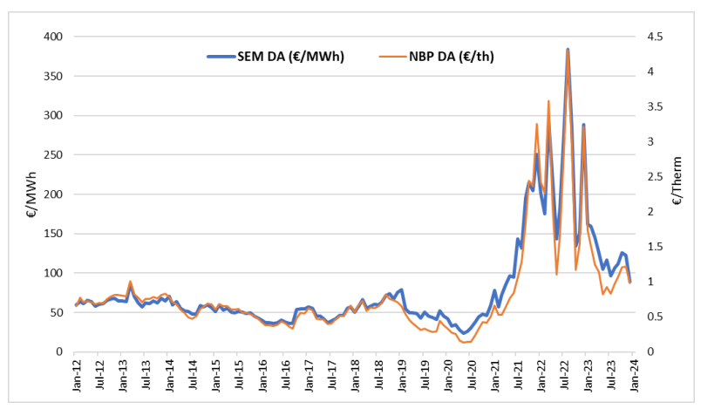
Figure 1 Source: CRU Energy Monitoring Report for 2023
Case Study of the 2022 Supply Shock
The 2022 energy price rises precipitated by Russia’s invasion of Ukraine offers insight into possible longer-term price dynamics, and a reference point to evaluate potential policy responses. The case study emphasises that an immediate policy response to closure of the Strait of Hormuz is necessary and must be complemented with a longer-term approach to manage extended disruption.
The extent of the 2022 supply shock is summarised as follows (Commission for Regulation of Utilities, 2024):
- In the first half of 2022, annual household electricity prices in Ireland increased by 26% relative to the previous year, and a further 21% in the second half of the year.
- Gas prices increased by 24% in the first half of 2022, and a further 19% in the second half of the year. Supplier hedging smoothed the spike compared to the rest of the Euro Area.
- By the end of March 2022, annual respective increases in the retail price of diesel and petrol of 32% and 25% were recorded.
The 2022 government response was quick and decisive, helping limit the effect of price spikes. Excise duties on oil products were reduced, a €200 energy credit was provided to all households, and a further €125 lumpsum was delivered to vulnerable households within one month. A month after this the National Energy Security Framework (NESF) was published, outlining thirty-one policy measures (Department of Climate, 2022). The actions were grouped under three headings:
- Managing the Impact on Consumers and Businesses: Reducing excise duties had a measurable effect on the retail cost of fuel products. The price of diesel and petrol dropped significantly after implementation. Similarly, a 4.5% VAT reduction on gas and electricity bills supported consumers. However, a sustained rise in electricity prices necessitated three extra energy credit payments of €200. A campaign to raise awareness of energy saving measures was also launched. Participating organisations reported a reduction in their energy use, but engagement was limited. Further measures were targeted at financially vulnerable customers, helping them to restructure debt repayment and protect against electricity disconnection.
- Ensuring Security of Supply in the near-term: The actions in this section were primarily contingency plans to prepare for disruption and highlighting our dependency on imports. Release of strategic oil stock helped regulate market prices, emphasising the need to develop similar reserves for natural gas.
- Reducing our dependency on imported fossil fuels: A set of priority energy infrastructure projects were selected for acceleration. Alignment of the planning system was identified as a necessary step to accelerate project rollout. Analysis below shows a lack of progress in this area. A security of supply review was called for which has since led to plans to develop strategic natural gas reserves.
Towards the end of 2022 the government signed off on a windfall tax for energy companies making abnormal profits over 2022 and 2023, recouping much of the initial expense of the policy response.
Evaluation of our short-term response to the 2022 energy crisis must consider its context post-Covid 19. Pandemic restrictions were lifted fully only one month before Russia’s invasion of Ukraine. The Covid 19 policy response included significant monetary stimulus and partially accounts for the speed we were able to react in response to the 2022 energy crisis. It’s difficult to isolate the inflationary and growth effects of the energy crisis with the economy rebounding as restrictions lifted. Inflation rose strongly as Covid stimulus took effect and was further exacerbated when the energy crisis took effect. Monthly inflation eventually peaked at 9.6% in July 2022, taking two years to return close to target levels (European Central Bank, 2026). A concerning statistic linked to this is the increase of energy poverty from 17.5% in 2020 to 42% in 2023, indicating strongly that support for vulnerable households was insufficient (Kinnear & Julienne, 2025; O'Malley et al., 2020). On the other hand, Modified Total Domestic Demand continued its strong growth trajectory, illustrated in figure 2, through the energy crisis and the years following. The policy response successfully avoided wider damage to the economy, but support targeted at vulnerable households was insufficient.
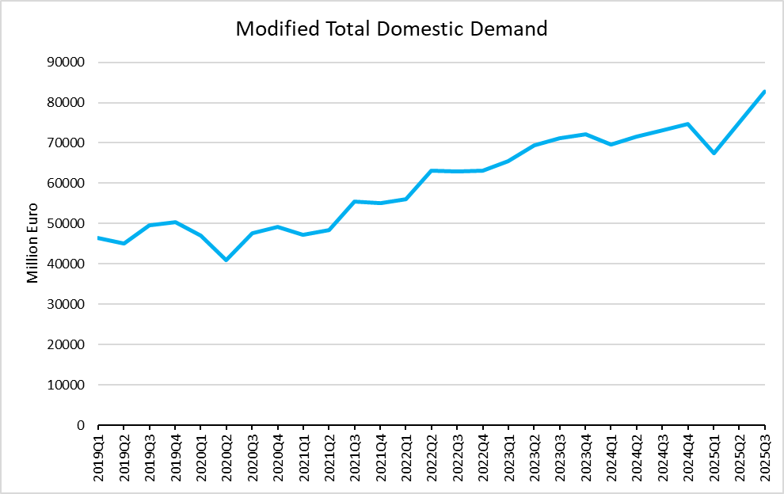
Figure 2 Data Source: CSO
Three years have passed since publication of the NESF, and the effectiveness of its longer-term actions can be evaluated. Action 25 highlighted the need to align elements of the planning system so that development of critical infrastructure could be accelerated. Analysis of quarterly capital expenditure reports from EirGrid indicates challenges remain (EirGrid, 2026):
- Between Q3 2022 and Q3 2025, the targeted completion of the North-South Interconnector has slipped from the end of 2025 to the end of 2031. This is primarily due to planning disputes.
- The Climate Action Plan targets 5GW of offshore wind generation by 2030 (Department of Climate, 2025). EirGrid’s most recent capital expenditure report does not contain a targeted delivery date for even the first offshore projects, highlighting a discrepancy between policy ambition and the reality of infrastructure delivery in Ireland (EirGrid, 2025).
A Strategic Gas Emergency Reserve has been under development since the 2022 prompted, security of supply review took place. Although the Shannon Estuary was last year announced as the location of the reserve, no further progress has been made public and no target date for the project’s completion has been announced.
Incremental policy and legal progress have been made since 2022, including a revision to the National Planning Framework and a government ‘Accelerating Infrastructure – Report and Action Plan’ outlining further changes to the planning system. Nevertheless, we are entering the current crisis essentially in the same position as we entered the 2022 crisis three years ago.

Policy Alternatives
Option 1: No Response
Energy poverty levels increased by 24% between 2020 and 2023, and it is likely this is largely attributable to the energy crisis of 2022. The effect is likely to have been much worse without the targeted supports in place during the crisis. Given that the current level of energy poverty is already high, it is safe to predict that closure of the Strait of Hormuz will quickly lead to widespread energy poverty unless mitigation measures are implemented.
Extended closure of the Strait is also likely to lead to a contagion effect on the wider economy. Energy prices are directly linked to competitiveness, particularly for data intensive industries including pharmaceuticals and semiconductor manufacturing (Astrov et al., 2015).
Option 2: Replicate the 2022 Response
Ireland was one of few European countries to opt for direct supports rather than regulation of retail energy prices. The policy response was cheap relative to other European countries and successfully protected economic growth (Sgaravatti et al., 2021).
The mechanisms to deliver VAT and excise duty cuts, energy credits, and targeted supports are already in place, and will be quick to restart. The programme is proven to be cheap and economically sound. Implementation of the framework can be overseen by the existing Energy Security Emergency Group (ESEG).
However given the rise in energy poverty, it may be argued that supports were inadequate. Furthermore, there is no evidence that plans to accelerate infrastructure delivery have had any material impact on key projects. On the contrary, critical projects have faced significant further delays since the plan was put in place.
Option 3: Augment the 2022 Response
The third option retains the largely successful framework of 2022, while augmenting these specific measures:
- Energy Credit Payments: Restart quarterly energy payments at €250. Remove 2022’s VAT and PSO adjustment, rolling their value into the direct payment. The value of the VAT reduction has been estimated at €13 per quarter (Department of Finance, 2025). An additional increase from 2022 of €37 is applied to adjust for inflation, and a possible PSO levy. This will increase visibility of the measure and streamline implementation. Additionally, there is imperfect competition in Ireland’s electricity supply market, implying that side-equivalence of subsidies does not hold. Delivering the energy credit directly to the consumer ensures the desired incidence. Significant budgetary surpluses ensure sufficient fiscal headroom needed to deliver this, and energy industry windfall taxes can be considered later to recoup the cost.
- Significantly expand targeted measures: Raise the existing Fuel Allowance by €5 per week, in-line with previous increases (Citizens Information, 2025b; Oireachtas, 2024). Increase the reporting frequency of energy poverty statistics so that a need for further increases can be monitored (Citizens Information, 2025a). Research by the ESRI argued that indirect tax cuts were ineffective, and ‘the arguments for lump-sum payments to recipients of welfare payments, increases in the Fuel Allowance and increasing PRSI credits are compelling’ (Barrett et al., 2022).
- Commit to delivering the Strategic Gas Emergency Reserve by December 2027. The infrastructure required is minimal as the storage facility itself is a ready-made LNG tanker and regassification unit. Fast tracking planning permits will bring this project to completion swiftly.
Option 4: 2022 Response + Coal
- Gas is currently the only fuel type that can provide a significant synchronous baseload to the country. The only credible way we can diversify is to restart coal production at Moneypoint power plant. The facility completed its transition away from coal mid-2025 and was the final facility to do so in the country. Restarting coal burning as an emergency backup could significantly reduce reliance on natural gas during the crisis and put downward pressure on prices.

Recommended Policy
Policy Option 3 is recommended. Although largely successful, a number of clear improvements should be made to the 2022 approach. Speed is of paramount importance and simplification will be support rapid delivery. Given the prevalence of energy poverty post 2022, there is a need to expand protective measures and increase monitoring. This is particularly relevant in the current climate of global protectionism.
Option 1 is not recommended because it is likely to cause widespread social and economic harm. Option 4 is not recommended due to questionable technical feasibility. The debate whether coal was phased out too quickly is valid, but restarting production now would be expensive. The timeframe required to restart supply chains and grant permitting is also highly uncertain.

Prepared by Blind Grade Number 120, Department for Finance, 22 January 2026.

References Consulted
Astrov, V., Hanzl-Weiss, D., Leitner, S. M., Pindyuk, O., Pöschl, J., & Stehrer, R. (2015). Energy Efficiency and EU Industrial Competitiveness: Energy Costs and their Impact on Manufacturing Activity [techreport](405). (wiiw Research Report, Issue. https://www.econstor.eu/handle/10419/204177
Barrett, M., Farrell, N., & Roantree, B. (2022). Energy Poverty and Deprivation in Ireland [techreport](144). (ESRI Research Series, Issue. https://www.esri.ie/system/files/publications/RS144.pdf
Central Statistics Office. (2023). Energy: A Value Chain Analysis 2020 – Producers [Statistical Release / Frontier Series Output]. https://www.cso.ie/en/releasesandpublications/fp/fp-evca/energyavaluechainanalysis2020/producers/
Central Statistics Office. (2025). Fuel or Energy Source Used for Heating [Statistical Release]. https://www.cso.ie/en/releasesandpublications/ep/p-hebeu/householdenvironmentalbehaviours-energyuse2024/fuelorenergysourceusedforheating/
Citizens Information. (2025a). Fuel Allowance. In. https://www.citizensinformation.ie/en/social-welfare/extra-social-welfare-benefits/fuel-allowance/
Citizens Information. (2025b). Social welfare payment changes in this year’s Budget. In. https://www.citizensinformation.ie/en/whats-new/social-welfare-payment-changes-in-this-years-budget/
Commission for Regulation of Utilities. (2024). Household Electricity & Gas Prices – Ireland and EU Comparison: Inform ation Note [Information Note](CRU202441). https://cruie-live-96ca64acab2247eca8a850a7e54b-5b34f62.divio-media.com/documents/Household-Electricity-and-Gas-Prices-Ireland--EU-Comparison-Information-Note.pdf
Department of Climate, E. a. t. E. (2022). National Energy Security Framework [Publication]. https://www.gov.ie/en/department-of-climate-energy-and-the-environment/publications/national-energy-security-framework/
Department of Climate, E. a. t. E. (2025). Climate Action Plan 2025: Main Report [techreport]. https://assets.gov.ie/static/documents/c491032e/DECC_Climate_Action_Plan_2025_Main_Report_-_Final_Web.pdf
Department of Finance. (2025). Government approves further 6 month extension of 9% VAT on gas and ele ctricity. In. https://www.gov.ie/en/department-of-finance/press-releases/government-approves-further-6-month-extension-of-9-vat-on-gas-and-electricity/
EirGrid. (2025). Network Delivery Portfolio (NDP) Guidance Document – Q3 2025 [Guidance Document]. https://cms.eirgrid.ie/sites/default/files/2025-10/NDP_Guidance_Document_Q3_2025_0.pdf
EirGrid. (2026). Network Delivery Portfolio (NDP). In. https://www.eirgrid.ie/grid/grid-reports-and-planning/network-delivery-portfolio
Esb. (2025). Electricity Costs in Ireland – Drivers, Outlook and Potential Interven tions [White Paper](July 2025). https://cdn.esb.ie/media/docs/default-source/ask/esb-white-paper-on-electricity-costs-july-2025.pdf?sfvrsn=24d0ae07_5
European Central Bank. (2026). Harmonised Index of Consumer Prices (HICP), Monthly – Ireland, Annual Rate of Change (ICP.M.IE.N.000000.4.ANR). In. https://data.ecb.europa.eu/data/datasets/ICP/ICP.M.IE.N.000000.4.ANR
Kinnear, L., & Julienne, H. (2025). Energy Poverty in Ireland: Analysis of 2023 data from the Behavioural Energy and Travel Tracker [Behavioural Insights for Policy: Primary Research]. https://www.seai.ie/sites/default/files/publications/bett-energy-poverty-in-ireland.pdf
O'Malley, S., Roantree, B., & Curtis, J. (2020). Carbon Taxes, Poverty and Compensation Options [techreport](98). (ESRI Survey and Statistical Report Series, Issue. https://www.esri.ie/system/files/publications/SUSTAT98_0.pdf
Oireachtas. (2024). Parliamentary Question No. 693 – Social Welfare Schemes, Tuesday 5 Nov ember 2024. In. https://www.oireachtas.ie/en/debates/question/2024-11-05/693/
Parliamentary Budget Office. (2022). An Overview of Ireland’s Electric Vehicle Incentives and a Comparison with International Peers [Publication 12 of 2022]. https://data.oireachtas.ie/ie/oireachtas/parliamentaryBudgetOffice/2022/2022-06-02_an-overview-of-ireland-s-electric-vehicle-incentives-and-a-comparison-with-international-peers_en.pdf
Sgaravatti, G., Tagliapietra, S., Trasi, C., & Zachmann, G. (2021). National policies to shield consumers from rising energy prices. In: Bruegel. https://www.bruegel.org/dataset/national-policies-shield-consumers-rising-energy-prices
Sustainable Energy Authority of Ireland. (2024). Energy in Ireland 2024 [Technical Report](EII-2024-1.0). https://www.seai.ie/sites/default/files/publications/energy-in-ireland-2024.pdf
TheGlobalEconomy.com. (2026). Rural population, percent – European Union. In. https://www.theglobaleconomy.com/rankings/rural_population_percent/European-union/

Price rises calculated using mid-point estimates of annual household spends.
EU regulation requires Ireland to keep 90 days of oil stocks. We participated in the International Energy Agency’s multilateral coordinated release of stocks in the aftermath of the energy crisis.
Energy Poverty is typically defined as spending more than 10% of disposable income on energy costs.
Modified Total Domestic Demand is a measure of the economy. It adjusts for flaws in the GDP metric when applied to the Irish economy.
The Public Service Obligation (PSO) levy varies annually but is not a significant component of customer bills.
Synchronous generators are needed on the Irish grid to stabilise fluctuations in wind and solar.

